Chapter 3 Pythagorean Relationship

Section 3.1 Squares and Square Roots

Section 3.1 Page 85 Question 5

a) 4 The prime factorization of 4 is 2 × 2.

2 2

b) Yes, the number 4 is a perfect square because each prime factor occurs an even number of times.

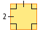
c)
Area: 2 × 2 = 4

Section 3.1 Page 85 Question 6

a) 64 The prime factorization of 64 is 2 × 2 × 2 × 2 × 2 × 2.

8 8

4 2 2 4

2 2 2 2 2 2

b) Yes, 64 is a perfect square. The prime factor, 2, appears an even number (6) of times.
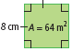
c)
Area: 8 × 8 = 64

Section 3.1 Page 85 Question 7

a) 42

The prime factorization of 42 is 2 × 3 × 7.
6 7

2 3 7

The number 42 is not a perfect square because each prime factor does not occur an even number of times in its prime factorization.

b) 169

The prime factorization of 169 is 13 × 13.
13 13

The number 169 is a perfect square because it has an even number of prime factors in the prime factorization.

c) 256

16 16 The prime factorization of 256 is 2 × 2 × 2 × 2 × 2 × 2.

4 4 4 4

2 2 2 2 2 2 2 2

The number 256 is a perfect square because it has an even number (6) of identical prime factors in the prime factorization.

Section 3.1 Page 85 Question 8

a) 144

12 12
The prime factorization of 144 is 2 × 2 × 2 × 2 × 3 × 3.
3 4 3 4

3 2 2 3 2 2

The number 144 is a perfect square because the prime factors 2 and 3 appear an even number times in the prime factorization.

b) 60

6 10 The prime factorization of 60 is 2 × 2 × 3 × 5.

2 3 2 5

The number 60 is not a perfect square because the factors 3 and 5 appear an odd number of times in the prime factorization.

c) 40

4 10 The prime factorization of 40 is 2 × 2 × 2 × 5.

2 2 2 5

The number 40 is not a perfect square because the factors 2 and 5 appear an odd number of times in the prime factorization.

Section 3.1 Page 85 Question 9

a) A = s²
A = 10²
A = 10 × 10
A = 100
The area of the square is 100 square units.

b) A = s²
A = 16²
A = 16 × 16
A = 256
The area of the square is 256 square units.

Section 3.1 Page 85 Question 10

a) A = s²
A = 20²
A = 20 × 0
A = 400
The area of the square is 400 square units.

b) A = s²
A = 17²
A = 17 × 17
A = 289
The area of the square is 289 square units.

Section 3.1 Page 85 Question 11

a) 9 × 9 = 81

b) 11 × 11 = 121

Section 3.1 Page 85 Question 12

a) 3 × 3 = 9

b) 18 × 18 = 324

Section 3.1 Page 85 Question 13

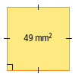
The prime factorization of 49 is 7 × 7.
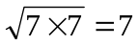
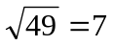
The side length is 7 mm.

Section 3.1 Page 86 Question 14

900

- 90

2 5 9 10

2 5 3 3 2 5

The prime factorization of 900 is 2 × 2 × 3 × 3 × 5 × 5

Rearrange the prime factors into two equal groups.

900 = 2 × 3 × 5 × 2 × 3 × 5

900 = 30 × 30
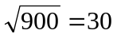

The side length is 30 cm.

Section 3.1 Page 86 Question 15

a) The prime factorization of 49 is 7 × 7.

b) The prime factorization of 64 is 2 × 2 × 2 × 2 × 2 × 2.
Rearrange the prime factors into two equal groups.

64 = 2 × 2 × 2 × 2 × 2 × 2

64 = 8 × 8
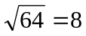

c) The prime factorization of 625 is 5 × 5 × 5 × 5.
Rearrange the prime factors into two equal groups.

625 = 5 × 5 × 5 × 5

625 = 25 × 25
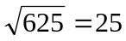

Section 3.1 Page 86 Question 16

a) The prime factorization of 9 is 3 × 3: 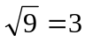

b) The prime factorization of 25 is 5 × 5: 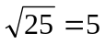

c) The prime factorization of 1600 is 2 × 2 × 2 × 2 × 2 × 2 × 5 × 5.
Rearrange the prime factors into two equal groups.

1600 = 2 × 2 × 2 × 5 × 2 × 2 × 2 × 5

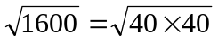
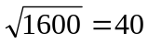

Section 3.1 Page 86 Question 17

54

- 9 The prime factorization of 54 is 2 × 3 × 3 × 3.

2 3 3 3

The number 54 is not a perfect square because each prime factor does not occur an even numbers of times.

Section 3.1 Page 86 Question 18

The side length of the floor mat is 14 m.
14 × 14 = 196

The area of the floor mat is 196 m².

Section 3.1 Page 86 Question 19

Calculate the side the length of the field:
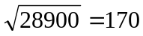
The side length of the field is 170 m.

Determine the perimeter of the field:
4 × 170 = 680
The perimeter of the field is 680 m.

Double the perimeter to find the distance twice around the field:
2 × 680 = 1360

The students ran 1360 m.

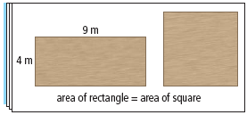
Section 3.1 Page 86 Question 20

a) 4 × 9 = 36
The area of the square is 36 m².
b)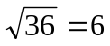
The side length of the square is 6 m.
Section 3.1 Page 86 Question 21

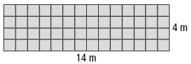
a) 4 × 14 = 56
The area of the patio is 56 m².
b) The following rectangular patios could be built: 1 m by 56 m; 2 m by 28 m; 7 m by 8 m. Each of these sets of dimensions are factor pairs of 56.
c) No, it is not possible to make a square patio with an area of 56 m² because 56 is not a perfect square.

Section 3.1 Page 86 Question 22

a)
396 900 divisibility rule for 100

- 3969 divisibility rule for 9

10 10 9 441 divisibility rule for 9

2 5 2 5 3 3 9 49

2 5 2 5 3 3 3 3 7 7

The prime factorization of 396 900 is 2 × 2 × 3 × 3 × 3 × 3 × 5 × 5 × 7 × 7.
Rearrange the prime factors into two equal groups:

396 900 = 2 × 3 × 3 × 5 × 7 × 2 × 3 × 3 × 5 × 7

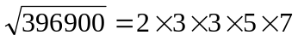
The dimensions of Tiananmen Square are 630 m × 630 m.

b) 629 × 629 = 395 641
The area of the square with side dimension of 629 m is 395 641 m².

c) The squares with whole number dimensions that have areas between 386 000 m² and 394 000 m² can be found by calculating the square roots of these values.

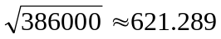
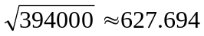

The squares could have a side length of 622 m, 623 m, 624 m, 625 m, 626 m, or 627 m.

Section 3.1 Page 86 Question 23

The prime factorization of 400 is 2 × 2 × 2 × 2 × 5 × 5.
Rearrange the prime factors into two equal groups:

400 = 2 × 2 × 5 × 2 × 2 × 5
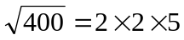

The side length of the helicopter landing pad is 20 m.

Section 3.1 Page 87 Question 24
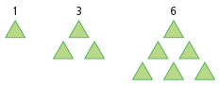
a) The difference between consecutive triangular numbers increases by one:
1, 3, 6, 10, 15, 21…..
+2 +3 +4 +5 +6
The next three triangular numbers are: 10, 15, and 21.
To find the n^{th} triangular number you can use the formula: 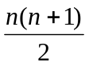. For example, the sixth triangular number is: 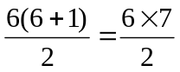
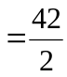
= 21

b) The sums of two consecutive triangular numbers are: 4, 9, 16, 25, 36….. The sums are always perfect squares. This relation can be shown visually as follows:
1 + 3 = 4 3 + 6 = 9

Section 3.1 Page 87 Question 25

a)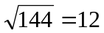
The side length of the digital photo is 12 cm.

b) 36 × 36 = 1296
The area of the new enlarged photo is 1296 cm².

c) 1296 ÷ 144 = 9
The area of the enlarged photo is 9 times bigger than the area of the original photo.

d) 36 ÷ 12 = 3
The side length is 3 times as large in the enlarged photo.

e) The area of the original photo is 144 or 12 × 12. The area of the enlarged photo is 1296 or (12 × 3) × (12 × 3). The difference between these two areas is two factors of 3, which equals 3² (or 9). Therefore, the side length of the larger photo is 3 times the size and the area is 3² or 9 times larger. To find the number of times the side length is enlarged, calculate the square root of the times that the area has been enlarged.

Section 3.1 Page 87 Question 26

a) The two perfect squares are 100 and 10 000. These are the only two numbers which have an even number of prime factors in their prime factorizations.
100 = 2 × 2 × 5 × 5
10 000 = 2 × 2 × 2 × 2 × 5 × 5 × 5 × 5

b)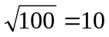; 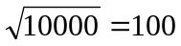

c) Answers may vary. Example: The number 100 000 is not a perfect square. The prime factorization of 100 000 is 2 × 2 × 2 × 2 × 2 × 5 × 5 × 5 × 5 × 5.
There is an odd number of factors 2 and 5 in the prime factorization.

d) For numbers which are powers of 10, if there is an even number of trailing zeros, then the number is a perfect square. For example, the first five powers of 10 which are perfect squares would be: 100, 10 000, 1 000 000, 100 000 000, and 10 000 000 000.

e) One billion or 1 000 000 000 is not a perfect square because it has an odd number of trailing zeros (9). A calculator can be used to verify that it is not a perfect square.

Section 3.1 Page 87 Question 27

a)
Perfect square | 6400 | 640 000 | 64 000 000
Square root | 80 | 800 | 8000

b) Take the square root of 64 and then “add” half the number of trailing zeros from the original number.

c) There is an odd number of trailing zeros for 640 so it is not a perfect square.

d)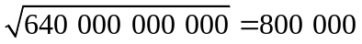. Calculate the square root of 64, which is 8. Then count the number of trailing zeros, which is 10. Take half of that number of trailing zeros, which is 5, and attach that many zeros to 8.

Section 3.2 Exploring the Pythagorean Relationship

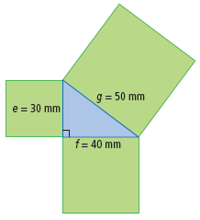
Section 3.2 Page 92 Question 4

e = 30 mm
A = 30²
A = 900
The area is 900 mm².

f = 40 mm
A = 40²
A = 1600
The area is 1600 mm².

g = 50 mm
A = 50²
A = 2500
The area is 2500 mm².

Section 3.2 Page 92 Question 5

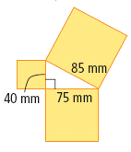
a)

Side length | 40 mm | 75 mm | 85 mm
Dimensions of squares | 40 mm × 40 mm | 75 mm × 75 mm | 85 mm × 85 mm
Areas of squares | 1600 mm² | 5625 mm² | 7225 mm²
b)

c) The sum of the areas of the two smaller squares is equal to the area of the largest square:
1600 + 5625 = 7225

Section 3.2 Page 92 Question 6
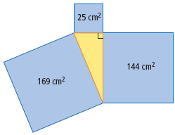
a) The sum of the areas of the two smaller squares is equal to the area of the largest square: 25 + 144 = 169.

b) smallest square: middle square: largest square:
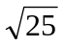= 5 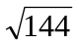= 12 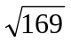= 13
The side length is 5 cm. The side length is 12 cm. The hypotenuse is 13 cm.

c) The sum of the areas of the two smaller squares is equal to the area of the largest square: 5² + 12² = 13²
25 + 144 = 169

Section 3.2 Page 92 Question 7

a) smallest square: middle square: largest square:
9 × 9 12 × 12 15 × 15
The area is 81 cm². The area is 144 cm². The area is 225 cm².

b) 81 + 144 = 225

c) The sum of the areas of the two smaller squares is equal to the area of the largest square: 9² + 12² = 15².

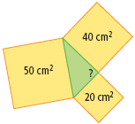
Section 3.2 Page 92 Question 8

No, the triangle is not a right triangle. The sum of the areas of the smaller squares is not equal to the area of the largest square: 20² + 40² ≠ 50².

Section 3.2 Page 92 Question 9
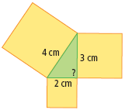
a)

Side length (cm) | 2 | 3 | 4
Area of Square (cm²) | 2 × 2 = 4 | 3 × 3 = 9 | 4 × 4 = 16

b) No, the triangle is not a right triangle. The sum of the areas of the smaller squares is not equal to the area of the largest square: 4 + 9 ≠ 16.

Section 3.2 Page 92 Question 10

Check whether the sum of the areas of the two smaller squares is equal to the area of the largest square:
120² + 160² = 200²
14400 + 25600 = 40000

Since the sum of the areas of the smaller squares is equal to the area of the larger square, the triangle is a right triangle.

Section 3.2 Page 92 Question 11

Check whether the sum of the areas two smaller squares is equal to the area of the largest square:
Does 5² + 6² equal 8²?
25 + 36 ≠ 64

Since the sum of the areas of the smaller squares is not equal to the area of the larger square, the triangle is not a right triangle.

Section 3.2 Page 93 Question 12

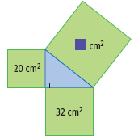
a) 20 + 32 = 52
The area of the square attached to the hypotenuse is 52 cm².

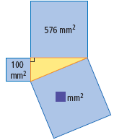
b) 100 + 576 = 676
The area of the square attached to the hypotenuse is 676 mm².

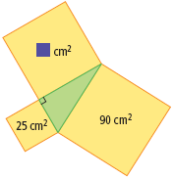
c) 90 – 25 = 65
The area of the square attached to the larger leg is 65 cm².

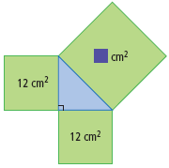
d) 12 + 12 = 24
The area of the square attached to the hypotenuse is 24 cm².
Section 3.2 Page 93 Question 13
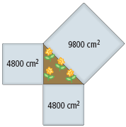
No, the garden is not a right triangle. The sum of the areas of the smaller squares is not equal to the area of the largest square: 4800 + 4800 ≠ 9800.

Section 3.2 Page 93 Question 14

Triangle | Side Lengths (cm) | a² + b² = c² | Right-angled?
A | 9, 12, 15 | 81 + 144 = 225 | Yes
B | 7, 8, 11 | 49 + 64 ≠ 121 | No
C | 7, 24, 25 | 49 + 576 = 625 | Yes
D | 16, 30, 34 | 256 + 900 = 1156 | Yes
E | 10, 11, 14 | 100 + 121 ≠ 196 | No

Section 3.2 Page 93 Question 15
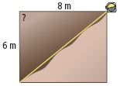
No, the angle is not a right angle. The diagonal would have to be 10 m, not 9.5 m, for the angle to be right angled: 6² + 8² ≠ 9.5².

Section 3.2 Page 93 Question 16

Answers may vary. Example: Baldeep should ensure that the sum of the areas of the squares for the width and the length of the rectangle equals the area of the square that can be drawn on the diagonal of the rectangle: 144 + 400 = 544.
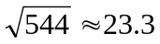
Therefore, the diagonal should be approximately 23.3 cm.

Section 3.2 Page 94 Question 17

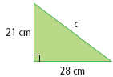
a) Area of the square that can be drawn on side c:
= 21² + 28²
= 441 + 784
= 1225
The area of the square is 1225 cm².

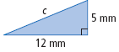
b) Area of the square that can be drawn on side c:
= 12² + 5²
= 144 + 25
= 169
The area of the square is 169 mm².

Section 3.2 Page 94 Question 18
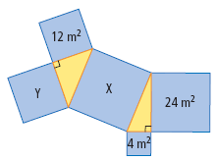
a) 4 + 24 = 28
The area of square X is 28 m².

b) 28 – 12 = 16
The area of square Y is 16 m².

Section 3.2 Page 94 Question 19

There are two possible solutions. The larger square, 15 cm², can be attached to:
the hypotenuse of the right triangle or the longer leg of the right triangle
Area of the third square: 15 – 10 = 5 cm² Area of the third square: 10 + 15 = 25 cm²
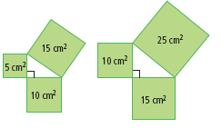

Section 3.2 Page 94 Question 20

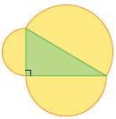
Answers may vary. Example:

Side length of the triangle (cm) | Radius of the semicircle (cm) | Area of semicircle 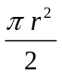 (cm²)
3 | 1.5 | 3.5
4 | 2.0 | 6.3
5 | 2.5 | 9.8

The sum of the areas of the two smaller semicircles is equal to the area of the semicircle attached to the hypotenuse of the triangle: 3.5 + 6.3 = 9.8.

Section 3.2 Page 94 Question 21

a) The new sides are:
3 × 2, 4 × 2, 5 × 2 or 6, 8, and 10
These three sides represent the sides of a right triangle since: 6² + 8² = 10².

b) Answers may vary. Example: If the sides are multiplied by 4, then the new sides are 12, 16, and 20. These three numbers form a Pythagorean triple since: 12² + 16² = 20².

c) No, there is no natural number that does not make a Pythagorean triple when 3, 4, and 5 are multiplied by it. When a positive number is multiplied by each side, a new triangle is created that is similar to the previous triangle. Similar triangles have congruent angles. Therefore, the right angle will be maintained between the two legs.

Section 3.3 Estimating Square Roots

Section 3.3 Page 99 Question 4
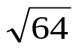
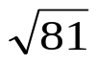
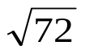
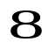
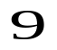
a) Since 72 is almost exactly half way between
the perfect squares 64 and 81, then 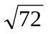≈ 8.5.

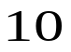
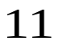
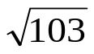
b) Since 103 is much closer to the perfect square 100
than the perfect square 121, then 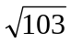≈ 10.1.

c) Since 55 is slightly closer to 49 than 64, then a reasonable estimate for 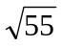is 7.4.

Section 3.3 Page 99 Question 5
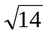
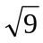
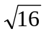

a)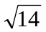≈ 3.7

b)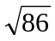≈ 9.3

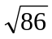
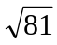
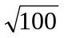

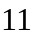
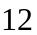
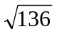
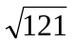
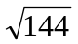
c)≈ 11.7

Section 3.3 Page 99 Question 6

The square of 9 is 81 and the square of 10 is 100. Any number between 81 and 100, inclusive, will have a square root between 9 and 10. For example, the number 90 has a square root between 9 and 10:
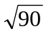≈ 9.49

Section 3.3 Page 99 Question 7

The square of 11 is 121 and the square of 12 is 144. Any number between 121 and 144 will have a square root between 11 and 12. For example, the number 130 has a square root between 121 and 144:
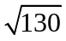≈ 11.40

Section 3.3 Page 99 Question 8

The square of 2 is 4 and the square of 3 is 9. All values that are larger than 4 and smaller than 9 are correct: 5, 6, 7, and 8.

Section 3.3 Page 99 Question 9

The square of 4 is 16 and the square of 5 is 25. All values that are larger than 16 and smaller than 25 are correct: 17, 18, 19, 20, 21, 22, 23, and 24.

Section 3.3 Page 99 Question 10

Calculate the square root of 27:
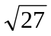 ≈ 5.2
The side length of the square backdrop is about 5.2 m.

Section 3.3 Page 99 Question 11
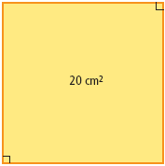
a) Determine the perfect squares on either side of 20:
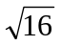= 4
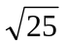= 5

Since 20 is almost halfway between the perfect squares 16 and 25, then a reasonable estimate for the square root of 20 is 4.5 cm.

b) Using a ruler to measure the side of the square on the diagram, the side length of the square is 4.5 cm.

Section 3.3 Page 99 Question 12

a) The number 11 is located between the perfect squares 9 and 16. Since it is closer to 9, then a reasonable estimate for the side length of the square rug is 3.2 m.

b) With a calculator, the approximate value is of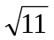is 3.3.

c) Yes, the rug will fit since its side length, 3.3 m, is smaller than the shorter side of the room, 4 m.

Section 3.3 Page 99 Question 13

a) Using a calculator: 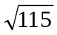 ≈ 10.7
The side length of the dance floor is 10.7 m.

b) Stella could choose a dance floor with a side length of 10 m or 11 m.

c) 10² = 10 × 10 or 11² = 11 × 11
= 100 = 121
The areas of the two possible square dance floors are 100 m² and 121 m².

d) Since 115 is closer to 121 than 100, she will most likely choose the larger dance floor.

Section 3.3 Page 100 Question 14

a) The number must be between 7² (49) and 8² (64). The only number in this range that is a multiple of 12 is 60.

b) No, there are not any other multiples of 12 between 49 and 64.

Section 3.3 Page 100 Question 15

To order the numbers from least to largest, calculate the two radical expressions and then compare:
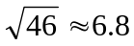 and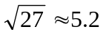
5.2, 5.8, 6.3, 6.8, 7
The correct order from smallest to largest is:, 5.8, 6.3,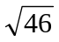, and 7.

A second method to solve this problem is to compare square roots. Convert the non-radical numbers to their square root equivalents:
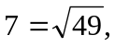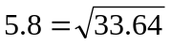, and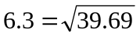.
Order these radical expressions: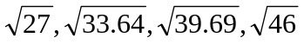, and 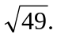
The correct order is:, 5.8, 6.3,, and 7.

Section 3.3 Page 100 Question 16

a) Find 75% of 36: 0.75 × 36 = 27
The maximum area of the hot tub is 27 m².

b) Determine the side length of a square with an area of 27 m²:
≈ 5.196

The fitness centre should order dimensions of 5.1 m by 5.1 m so that the area does not exceed 75% of the space available.

Section 3.3 Page 100 Question 17

a) Find the square of 18:
18 × 18 = 324
The area of the picture is 324 cm².

b) Calculate four times the area:
4 × 324 = 1296
The area of the board is 1296 cm².

c) Find the side length of the board:
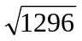= 36
The dimensions of the board are 36 cm by 36 cm.

Section 3.3 Page 100 Question 18

a)

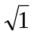
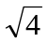
b) Answers may vary. Example:
≈ 1.7

c) Using a calculator: ≈ 1.73.

d) Answers may vary. Example: The positive difference between the answers in parts b) and c) is: 1.73 – 1.7 = 0.03

Section 3.3 Page 100 Question 19

The number 160 100 is close to 160 000. The number 160 000 can be written as the product of three factors of two different perfect squares, 16 and 100:
160 000 = 16 × 100 × 100.
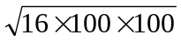= 4 ×10 × 10
= 400
A reasonable estimate for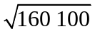 is 400.

Section 3.3 Page 100 Question 20

The prime factorization of 56 is:
56 = 2 × 2 × 2 × 7
Therefore, the expression 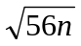 is equal to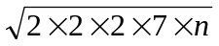.
To make the expression under the radical sign a perfect square, each prime factor must be paired up with an identical factor. A factor of 2 and a factor of 7 are required. Therefore, n = 2 × 7 = 14.

Section 3.3 Page 100 Question 21

First, determine the squares of 326 and 327:
326² = 106 276
327² = 106 929

The answers are between 106 276 and 106 929. Determine the numbers in this range that are divisible by 100. The following 7 numbers are multiples of 100 and within this range: 106 300, 106 400, 106 500, 106 600, 106 700, 106 800, and 106 900.
Determine which of these 7 numbers are multiples of 6. The only two numbers which are multiples of 6 are 106 500 and 106 800.
The two numbers are 106 500 and 106 800.

Section 3.4 Using the Pythagorean Relationship

Section 3.4 Page 104 Question 3

a) The length of the hypotenuse, c, can be found using the Pythagorean relationship:
c² = a² + b²
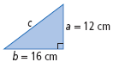
c² = 12² + 16²
c² = 144 + 256
c² = 400
c = 20
The length of the hypotenuse is 20 cm.

b) The length of the hypotenuse, r, can be found using the Pythagorean relationship:
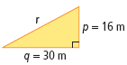
r² = p² + q²
r² = 16² + 30²
r² = 256 + 900
r² = 1156
r = 34
The length of the hypotenuse is 34 m.

Section 3.4 Page 104 Question 4

a) The hypotenuse, z, can be found using the Pythagorean relationship:
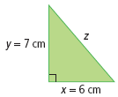
z² = x² + y²
z² = 6² + 7²
z² = 36 + 49
z² = 85
z = 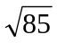≈ 9.2
The length of the hypotenuse is 9.2 cm.

b) The length of the hypotenuse, d, can be found using the Pythagorean relationship:
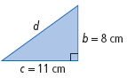
d² = b² + c²
d² = 8² + 11²
d² = 64 + 121
d² = 185
d = 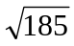≈ 13.6
The length of the hypotenuse is 13.6 cm.

Section 3.4 Page 104 Question 5
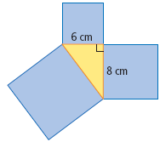
a) The area of each square attached to the two legs is: 6² or 36 cm² and 8² or 64 cm².

b) The area of the square attached to the hypotenuse is 100 cm² (36 + 64 = 100).

c) The length of the hypotenuse is equal to the side length of the square in part b). The length is or 10 cm.

Section 3.4 Page 104 Question 6

a) The length of the leg, b, can be found using the Pythagorean relationship:
a² + b² = c²
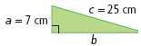
7² + b² = 25²
49 + b² = 625
b² = 625 – 49
b = 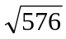
b = 24
The length of the leg is 24 cm.

b) The length of the leg, r, can be found using the Pythagorean relationship:
r² + s² = t²
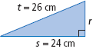
r² + 24² = 26²
r² + 576 = 676
r² = 676 – 576
r =
r = 10
The length of the leg is 10 cm.

Section 3.4 Page 104 Question 7

a) The length of the leg, h, can be found using the Pythagorean relationship:
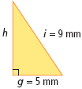
g² + h² = i²
5² + h² = 9²
25 + h² = 81
h² = 81 – 25
h = 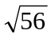
h = 7.5
The length of the leg is 7.5 mm.

b) The length of the leg, r, can be found using the Pythagorean relationship:
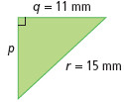
p² + q² = r²
p² + 11² = 15²
p² + 121 = 225
p² = 225 – 121
p = 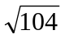
p = 10.2
The length of the leg is 10.2 mm.

Section 3.4 Page 104 Question 8

The length of the ramp, r, can be found by using the Pythagorean relationship:
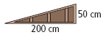
r² = 50² + 200²
r² = 2500 + 40000
r² = 42 500
r = 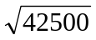≈ 206.16
The length of the ramp is approximately 206 cm.

Section 3.4 Page 104 Question 9

The length of the diagonal, d, can be found using the Pythagorean relationship:
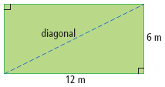
d² = 6² + 12²
d² = 36 + 144
d² = 180
d = 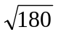≈ 13.4
The diagonal path will be 13.4 m long.

Section 3.4 Page 104 Question 10

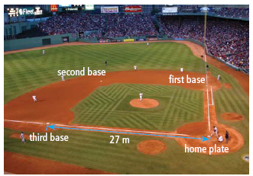
Let d represent the distance between third base and first base.
d² = 27² + 27²
d² = 729 + 729
d² = 1458
d = 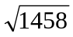≈ 38.2
The minimum distance the player at third base has to throw the ball to get the runner out at first base is
38.2 m.

Section 3.4 Page 105 Question 11
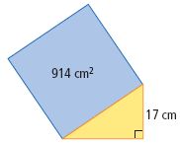
First, find the length of the unknown leg, x, using the Pythagorean relationship:
x² + 17² = 914
x² + 289 = 914
x² = 625
x = 25
The length of the leg, x, is 25 cm.

Then, find the length of the hypotenuse by finding the side length of the square:
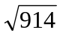≈ 30.2
The length of the hypotenuse is 30.2 cm.

Finally, calculate the perimeter of the triangle:
17 + 25 + 30.2 = 72.2

The perimeter of the triangle is 72.2 cm.

Section 3.4 Page 105 Question 12
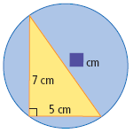
Use the Pythagorean relationship to find the hypotenuse, h, of the triangle:
h² = 5² + 7²
h² = 25 + 49
h² = 74
h = 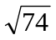
h ≈ 8.6

The diameter of the circle is the length of the hypotenuse, which is 8.6 cm.
Section 3.4 Page 105 Question 13
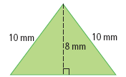
The height of the isosceles triangle is a bisector of the base. Therefore, half of the base, x, is the unknown leg of the right triangle with sides
8 mm and 10 mm.
x² + 8² = 10²
x² + 64 = 100
x² = 36
x = 6

The length of the base of the isosceles triangle is 12 mm.

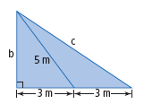
Section 3.4 Page 105 Question 14

First, calculate the length of side b:
b² + 3² = 5²
b² + 9 = 25
b² = 16
b = 4

Then, calculate the value of hypotenuse c for the right triangle with legs of 4 m and 6m:
c² = 4² + 6²
c² = 16 + 36
c² = 52
c = 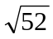
c ≈ 7.2

The length of side b is 4 m and the length of side c is 7.2 m.

Section 3.4 Page 105 Question 15
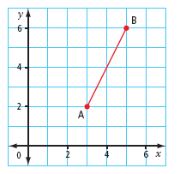
Consider the line segment AB to be the
hypotenuse of the right triangle. The lengths
of the legs are 2 units and 4 units.
AB² = 2² + 4²
AB² = 4 + 16
AB = 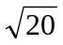
AB ≈ 4.47

The length of the line segment AB is 4.5 cm.

Section 3.4 Page 105 Question 16
C

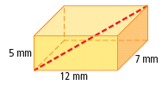
The length of AB can be found by applying
B
the Pythagorean relationship twice.
First, determine the length of AB:
AB² = 7² + 12²
A
AB² = 49 + 144
AB² = 193
AB = 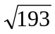

Then find the value of the space diagonal AC:
AC² = 5² + AB²
AC² = 25 + 193
AC² = 218
AC = 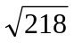
AC ≈ 14.8

The length of the space diagonal is 14.8 mm.

Section 3.5 Applying the Pythagorean Relationship

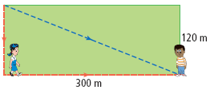
Section 3.5 Page 110 Question 3

a) 120 + 300 = 420
Maria walked 420 m.

b) Use the Pythagorean relationship to determine the distance, w, that Walter travelled:
w² = 120² + 300²
w² = 14 400 + 90 000
w = 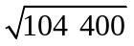
Walter walked 323 m.

c) 420 – 323 = 97
Maria walked 97 m further than Walter.

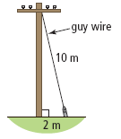
Section 3.5 Page 110 Question 4

The height of the pole, p, represents the leg of a right triangle:
h² + 2² = 10²
h² + 4 = 100
h = 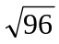

The height of the pole is 9.8 m.

Section 3.5 Page 110 Question 5

Yes, these dimensions could form a rectangle. Square both sides of the rectangle and then sum the values: 92 + 222 = 565.
Calculate the square root of 565:
= 23.8
This length is equal to the length of the diagonal.

Section 3.5 Page 110 Question 6

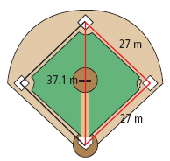
Determine the length of the hypotenuse, h, of the right triangle:
h² = 27² + 27²
h² = 729 + 729
h² = 1458
h =
h ≈ 38.2

The triangle is not a right triangle because there is not a right angle at first base. The distance between home plate and second base is 37.1 m, not 38.2 m.

Section 3.5 Page 110 Question 7

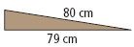
Find the height, h, of the wheelchair ramp using the Pythagorean relationship:
h² + 79² = 80²
h² + 6241 = 6400
h² = 159
h = 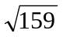≈ 12.6

The height, h, of the wheelchair ramp is 12.6 cm.

Section 3.5 Page 110 Question 8

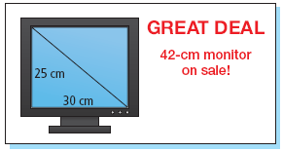
Calculate the diagonal, d, of the screen:
d² = 25² + 30²
d² = 625 + 900
d² = 1525
d = 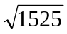
d ≈ 39.05

Shahriar is correct. The diagonal, d, is shorter than the advertised 42 cm.

Section 3.5 Page 110 Question 9

a) Calculate the diagonal, d, of a single 3 cm by 3 cm square:
d² = 3² + 3²
d² = 9 + 9
d = 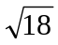
d ≈ 4.2

The diagonal of a small square is 4.2 cm.

b) Determine the diagonal, D, of the entire checkerboard:
D² = (3 × 8)² + (3 × 8)²
D² = 576 + 576
D = 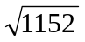
D ≈ 33.94

The length of the diagonal of the entire checkerboard is 34 cm.

Section 3.5 Page 110 Question 10

Determine the diagonal, d, of the 12 m by 12 m tumbling mat:
d² = 12² + 12²
d² = 144 + 144
d = 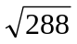
d ≈ 17.0

Since she needs 16 m to do her routine safely, she can use the mat as long as she tumbles along the diagonal of the mat.

Section 3.5 Page 111 Question 11

Find the minimum distance, m, that the ladder will reach up the wall:
m² + 110² = 300²
m² + 12 100 = 90 000
m² +12 100 – 12 100 = 90 000 – 12 100
m² = 77 900
m = 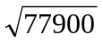 ≈ 279.1
The minimum distance that the ladder will reach up the wall is 279.1 cm.

Then find the maximum distance, d, that the ladder will reach up the wall:
d² + 70² = 300²
d² + 4900 = 90 000
d² + 4900 – 4900 = 90 000 – 4900
d² = 85 100
d = 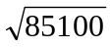 ≈ 291.7

The maximum distance that the ladder will reach up the wall is 291.7 cm.

Section 3.5 Page 111 Question 12
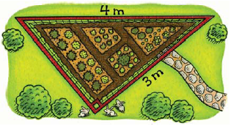
a) Calculate the missing side, x, of the triangular garden to determine the perimeter:
x² + 3² = 4²
x² + 9 = 16
x = 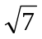
x ≈ 2.65

Find the perimeter, P:
P = 3 + 4 + 2.65

The perimeter of the garden is 9.65 m, so Sarah will need 9.65 m of fencing.

b) The cost of the fencing is: $2.00 × 9.65 = $19.30.

Section 3.5 Page 111 Question 13

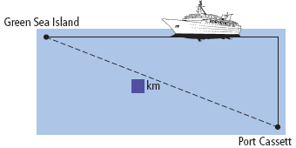
34 × 2.5 = 85
The distance the ship travelled north is 85 km.

30 × 7.3 = 219
The distance the ship travelled west is 219 km.

Apply the Pythagorean relationship to determine the distance, d, from Green Sea Island to Port Cassett:
d² = 85² + 219²
d² = 7225 + 47 961
d² = 55 186
d = 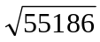
d ≈ 234.92

The ship is 235 km away from its starting location.

Section 3.5 Page 111 Question 14

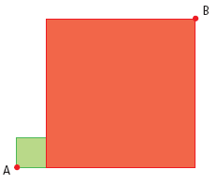
Determine the side lengths of the green and red squares:
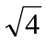= 2
The side length of the green square is 2 mm.
40 ÷ 4 = 10
The side length of the red square is 10 mm.

The shortest distance between A and B will be equivalent to the distance of the line segment AB. The line segment AB is the hypotenuse of a right triangle with legs that measure 10 mm and 12 mm.
AB² = 10² + 12²
AB² = 100 + 144
AB² = 244
AB = 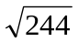
AB ≈ 15.62

The shortest distance between points A and B is 15.6 mm.

Chapter 3 Review

Chapter 3 Review Page 112 Question 1

The square root of 36 is 6.

Chapter 3 Review Page 112 Question 2

The number 25 is a perfect square because it is the product of the two identical prime factors, 5 × 5.

Chapter 3 Review Page 112 Question 3

In a right triangle, the longest side is known as the hypotenuse.

Chapter 3 Review Page 112 Question 4

If the sides of a right triangle are a, b, and c, and c is the longest side, the equation
c² = a² + b² is known as the Pythagorean relationship.

Chapter 3 Review Page 112 Question 5

The prime factorization of 18 is 2 × 3 × 3.

Chapter 3 Review Page 112 Question 6

a) 6² = 6 × 6
= 36

b) 11² = 11 × 11
= 121

c) 25² = 25 × 25
= 625

Chapter 3 Review Page 112 Question 7

a)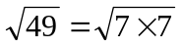
= 7

b)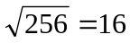

c)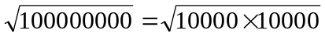
= 10 000

Chapter 3 Review Page 112 Question 8
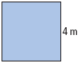
Find the area of the fabric:
4 × 4 = 16
The square piece of fabric has an area equal to 16 m². Since she needs 17 m² for the curtains, she does not have enough fabric.

Chapter 3 Review Page 112 Question 9

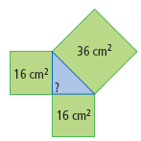
a) The sum of the areas of the two smaller squares is: 16 + 16 = 32.
The area 32 cm² does not equal the area of the largest square, which is
36 cm². Therefore, the triangle is not a right triangle.

b) The side lengths of the triangle are 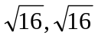, and 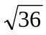.
These values are 4 cm, 4 cm, and 6 cm.

Chapter 3 Review Page 112 Question 10

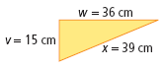
Check to see if the sum of the two shorter sides squared is equal to the square of the largest side:
15² + 36² = 39²
225 + 1296 = 1521

The triangle is a right triangle because the sum of the squares of the two smaller sides equals the square of the larger side.

Chapter 3 Review Page 112 Question 11

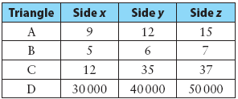
Triangles A, C, and D are all right-angled because the Pythagorean relationship holds true.
A: 9² + 12² = 15²
B: 5² + 6² ≠ 7²
C: 12² + 35² = 37²
D: 30 000² + 40 000² = 50 000²

Chapter 3 Review Page 112 Question 12

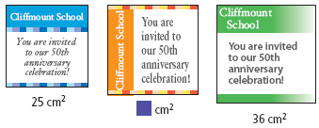
a) Any whole number between 25 and 36 would be a possible whole number area for this invitation. For example, 30 cm² would be approximately halfway between the areas of the first and third design.

b) The smallest design has a side length ofor 5 cm and the largest design has a side length of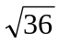or 6 cm.

c) Answers may vary. Example: For an area of 30 cm², a reasonable estimate would be 5.5 cm.

d) Answers may vary. Example: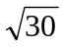≈ 5.5 cm

Chapter 3 Review Page 113 Question 13

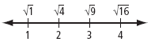
a) Since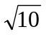is slightly larger than, a reasonable estimate foris 3.2.

b) The value of 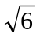is closer to 2 because 6 is closer to the perfect square 4 than it is to the perfect square 9.

c) When 3.61 is squared, the result is 13.0321. Therefore, 13 is the whole number which might have a square root approximation of 3.61.

Chapter 3 Review Page 113 Question 14

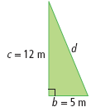
a) Use the Pythagorean relationship to find the hypotenuse:
d² = 5² + 12²
d² = 25 + 144
d² = 169
d = 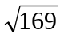
d = 13
The hypotenuse, d, is 13 m.

b) Use the Pythagorean relationship to find the missing side, v:
v² + 9² = 15²
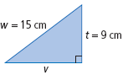
v² + 81 = 225
v² + 81 – 81 = 225 – 81
v² = 144
v =
v = 12
The length of side v is 12 cm.

Chapter 3 Review Page 113 Question 15

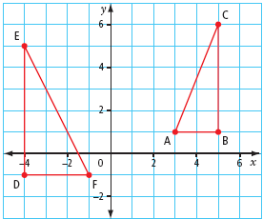
a) Find the length of hypotenuse, AB, in ∆ABC:
AB² = 2² + 5²
AB = 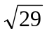
AB ≈ 5.4
The length of hypotenuse AB is 5.4 cm.

Find the length of hypotenuse, EF, in ∆DEF:
EF² = 3² + 6²
EF² = 9 + 36
EF = 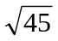
EF ≈ 6.7
The length of hypotenuse EF is 6.7 cm.

b) Find the perimeter of ∆DEF:
3 + 6 + 6.7 = 15.7

The perimeter of ∆DEF is 15.7 cm.

Chapter 3 Review Page 113 Question 16
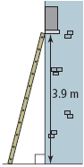
The length the ladder needs to reach is greater than 4 m:
1² + 3.9² ≈ 4.03²

No, the ladder will not reach the window.

Chapter 3 Review Page 113 Question 17
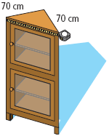
Find the hypotenuse, h, of the triangular top:
h² = 70² + 70²
h² = 4900 + 4900
h² = 9800
h = 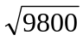
h ≈ 99.0

Yosef’s measurement should be 99.0 cm.

Chapter 3 Practice Test

Chapter 3 Practice Test Page 114 Question 1

D The number 100 is a perfect square because it has an even number of each prime factor: 100 = 2 × 2 × 5 × 5.

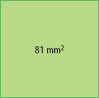
Chapter 3 Practice Test Page 114 Question 2

B The side length of the square will be or 9 mm.

Chapter 3 Practice Test Page 114 Question 3

D 7 × 7 = 49; The area of the square is 49 cm².

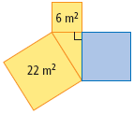
Chapter 3 Practice Test Page 114 Question 4

C 22 – 6 = 16; The area of the blue square is 16 m²

Chapter 3 Practice Test Page 114 Question 5

A The number 51 is between the perfect squares 49 and 64. Since 51 is closer to 49, then 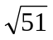is closer to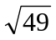. Sinceis 7 thenis closer to 7.

Chapter 3 Practice Test Page 114 Question 6

The variable that represents the hypotenuse is c in the Pythagorean relationship
c² = a² + b².

Chapter 3 Practice Test Page 114 Question 7

Find the side length of the square:
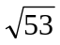≈ 7.3
The side length of the square is 7.3 cm.

Chapter 3 Practice Test Page 114 Question 8

a) Find the length of the hypotenuse, h:
h² = 3² + 7²
h² = 9 + 49
h² = 58
h = 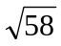
h ≈ 7.6158

The length of the hypotenuse is 7.6 cm.

b) Answers will vary. Example: Since 58 is not a perfect square, when the calculator displays the square root of 58, it can show only part of the decimal portion of the answer, so it is an approximation. When you round the answer, it is also an approximation because you are expressing the answer only to a certain decimal place.

Chapter 3 Practice Test Page 114 Question 9

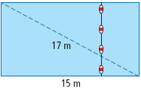
The float line will be equivalent to the width of the pool, w:
w² + 15² = 17²
w² + 225 = 289
w² = 64
w = 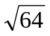
w = 8

The length of the float line is 8 m.

Chapter 3 Practice Test Page 114 Question 10

a) Determine the range of possible values by squaring 7 and 8:
7² = 49
8² = 64
Any values between 49 and 64 would be correct, including the boundary values of 49 and 64. For example, 50 is a whole number that has its square root between 7 and 8.

b) A total of 14 numbers have a square root between 7 and 8: 50, 51, 52, 53, 54, 55, 56, 57, 58, 59, 60, 61, 62, and 63.

Chapter 3 Practice Test Page 115 Question 11

Check whether the squared values of the two shorter sides has a sum equal to the square of the largest side:
14² + 48² = 50²
196 + 2304 = 2500

Yes, the triangle is a right triangle because the sum of the squares of the two shorter sides equals the square of the long side.

Chapter 3 Practice Test Page 115 Question 12

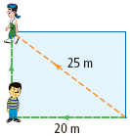
Use the Pythagorean relationship to determine the distance, d, that Han must travel:
d² + 20² = 25²
d² + 400 = 625
d² = 225
d = 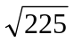
d = 15

Han must travel 15 m to meet up with Josie.

Chapter 3 Practice Test Page 115 Question 13

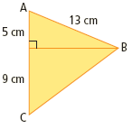
To find the perimeter of ∆ABC, first find the height, h, of the triangle using the Pythagorean relationship in ∆ABD:
h² + 5² = 13²
h² + 25 = 169
h² = 144
h = 12
The height of the triangle is 12 cm.

Second, find the length of BC using the right triangle ∆BDC:
BC² = 9² + 12²
BC² = 81 + 144
BC =
BC = 15
The length of BC is 15 cm.

Finally, determine the perimeter of ∆ABC:
5 + 9 + 13 + 15 = 42

The perimeter of ∆ABC is 42 cm.

Chapter 3 Practice Test Page 115 Question 14

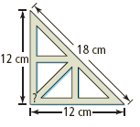
Apply the Pythagorean relationship to determine whether the carpenter’s square is a right triangle:
12² + 12² = 18²
144 + 144 = 324
288 ≠ 324

The carpenter’s square shown is not a right triangle. Answers may vary. Example: The sum of the squares of the two shorter sides does not equal the square of the long side.

Chapter 3 Practice Test Page 115 Question 15

a) Since each factor in the prime factorization of 15 876 appears an even number of times, then 15 876 is a perfect square.

b) The calculator sequencing to determine the square root of a number may vary depending on the type of calculator. A typical sequence would be:

C 1 5 8 7 6 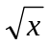

c) From the prime factorization of 15 876, take one prime factor from each identical pairing and then multiply to find the square root:

15 876 = 2 × 2 × 3 × 3 × 3 × 3 × 7 × 7

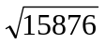= 2 × 3 × 3 × 7 = 126

The square root of 15 876 is 126.

